

  - Resource Clearinghouse
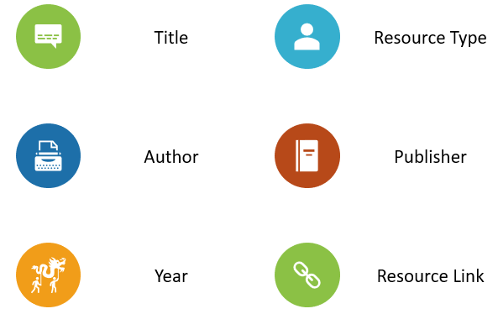
  - Going Global in a Generation

  - www.theglobalnowproject.com
  - info@theglobalnowproject.com

